BrokerForge how-to guide
Use a REST API from Dataverse the way K2 uses a service through SmartObjects: add a connection, answer BrokerForge's questions about the API, generate a table, and use it in lists and forms. All of it happens in the BrokerForge app in Dataverse.
Screenshots come from the BrokerForge dev environment and its mock APIs. Host and environment names are replaced with contoso placeholders. The video tools/media/out/brokerforge-how-to.mp4 walks through the same steps, with subtitles.
Contents
If you know K2
Part 1: add a REST connection (administrators)
Step 1: add the connection
Step 2: review and answer
Step 3: generate
Step 4: set the key
Step 5: use the table
Test and production
What fails, and why
Per-user services
Part 2: connect your account (everyone)
Where things live
When something goes wrong

If you know K2
In K2 you… | In BrokerForge you… | Step
Create a service instance: URL and authentication | Add a connection: base URL and authentication | 1
Point it at the service's description | Paste the service's Swagger (OpenAPI) definition into the connection | 1
Check the service objects K2 found | Review the endpoints and answer BrokerForge's questions | 2
Generate SmartObjects | Click Generate: table, columns, view, form, actions and a security role | 3
Enter the service account's password | Set the key on the host's page | 4
Use the SmartObject in views and forms | Use the table in Dataverse lists and forms | 5
Users enter their own credentials (OAuth, SSO) | Users connect their account on the connect page | Part 2

One difference: where a definition leaves a gap, such as how results are paged or which filters really work, BrokerForge asks rather than guessing. An endpoint isn't used until its questions are answered.

Part 1: add a REST connection (administrators)
You need the BrokerForge administrator role in the environment, and BrokerForge installed there (a one-off step, like installing a K2 server). Open the BrokerForge app and go to Connections.
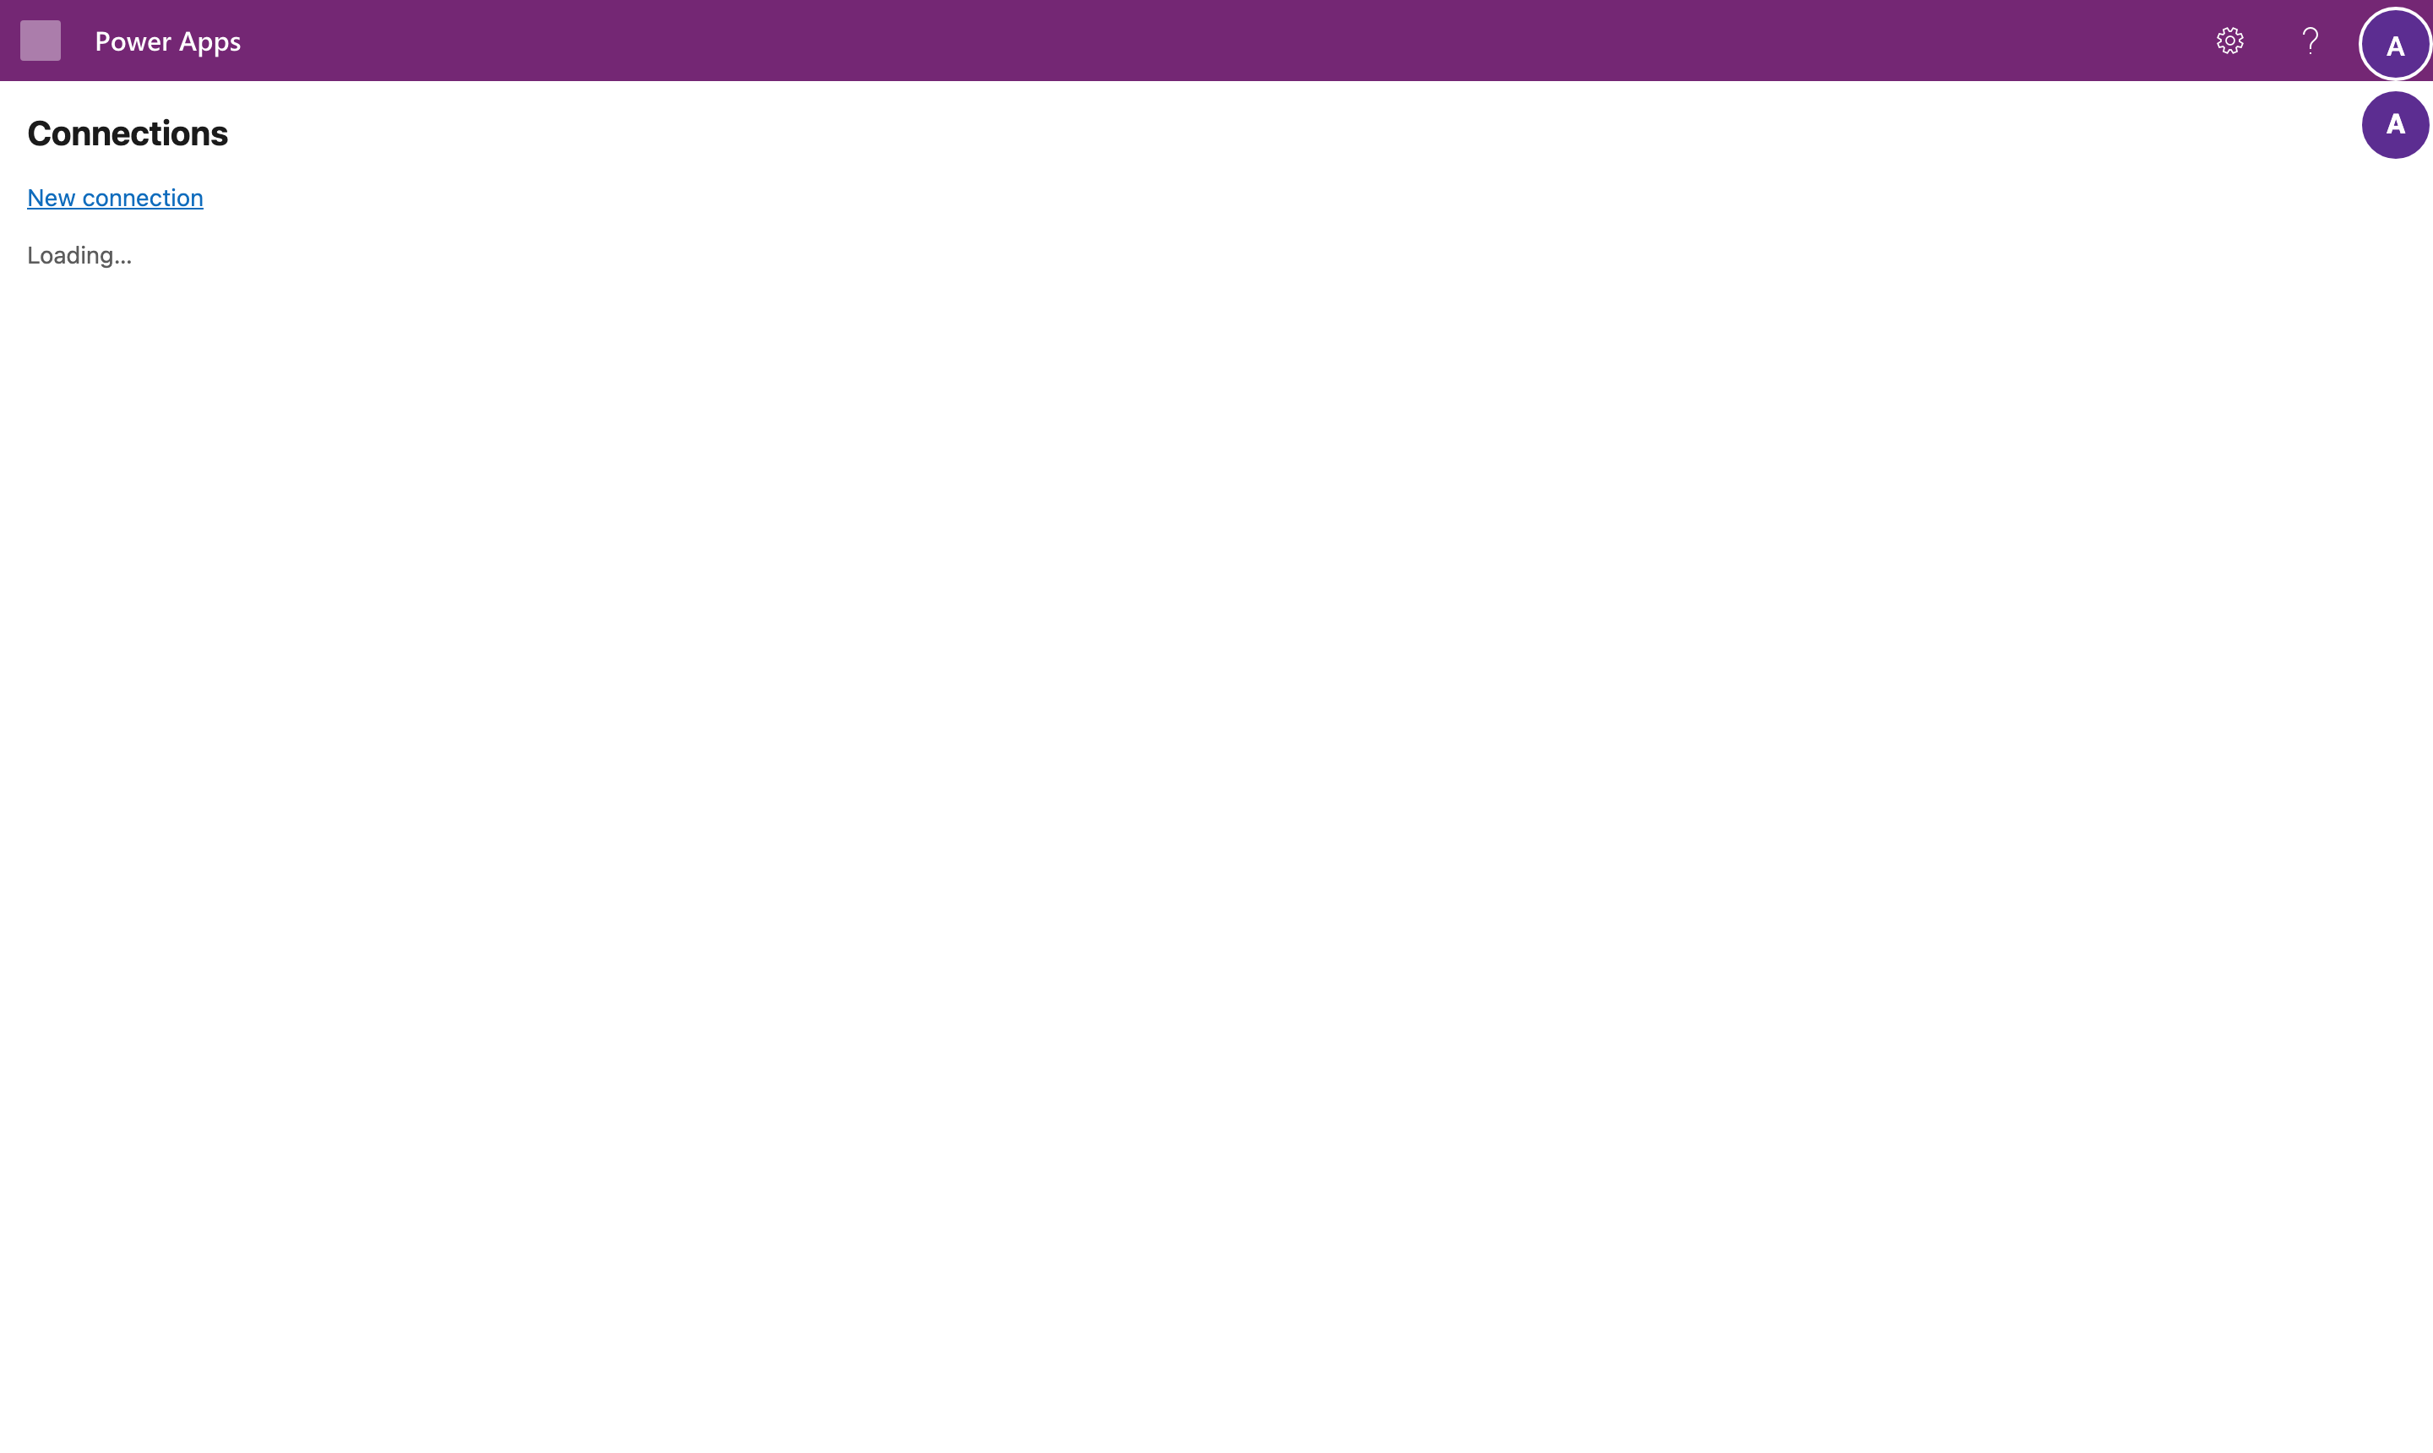
The example connects an inventory API.

Step 1: add the connection
Select New connection and fill in:
- Name, the name of the source, for example InventoryAPI;
- Base URL, where the API is;
- Authentication and the settings that mode needs. This API takes a key in its query string: Static, kind apiKeyQuery, query parameter api_key;
- Table prefix, your publisher's prefix, for example ext;
- Swagger / OpenAPI: paste the API's definition, YAML or JSON.
A key or password is never typed into this form. You set it on the host's page in step 4. Save the connection.
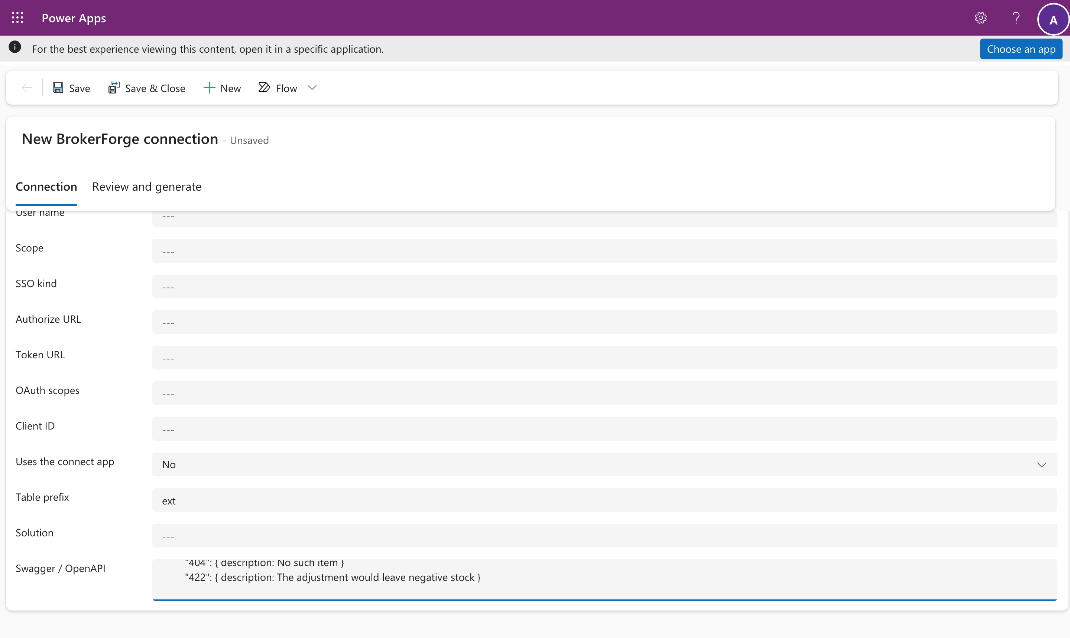

Step 2: review and answer
Open the Review and generate tab and select Save and read the definition. BrokerForge lists the table it proposes, with every column, and every endpoint with what it becomes: list, open, new, save, delete or an action. You can untick an endpoint, and rename columns.
Where the definition leaves a gap, a question appears under its endpoint: how results are paged, which filters the API really supports, whether its order is stable, how many decimal places a price has, where an error's message is. Generate stays disabled until every ticked endpoint is ready.
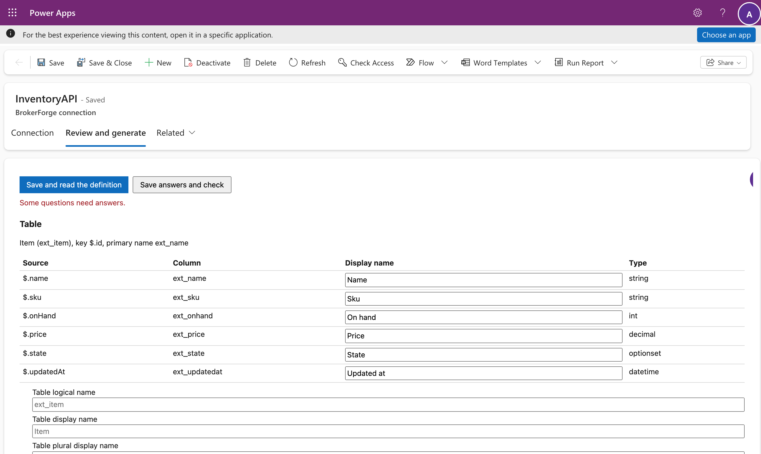
Answer them and select Save answers and check. When everything is ready, the page shows exactly what Generate will create or change.
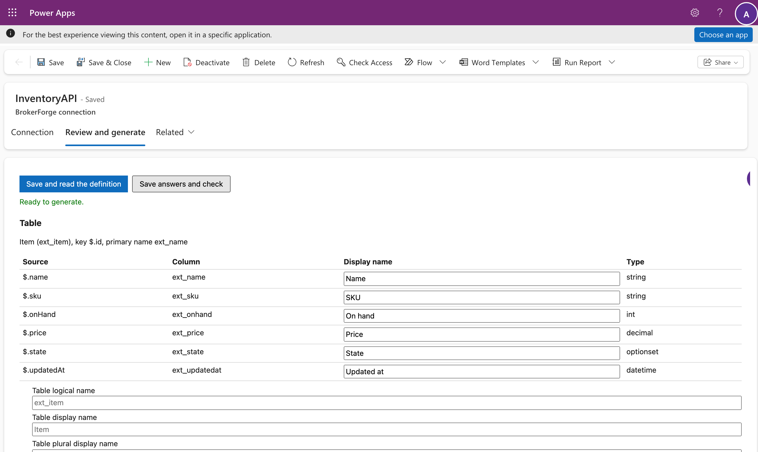

Step 3: generate
Select Generate. It runs in the background and the page follows it. It creates, in a solution named for the source:
- the virtual table and every column;
- a view and a main form that show every column;
- a Custom API for each action;
- a security role, <Name> user, with the privileges the endpoints allow.
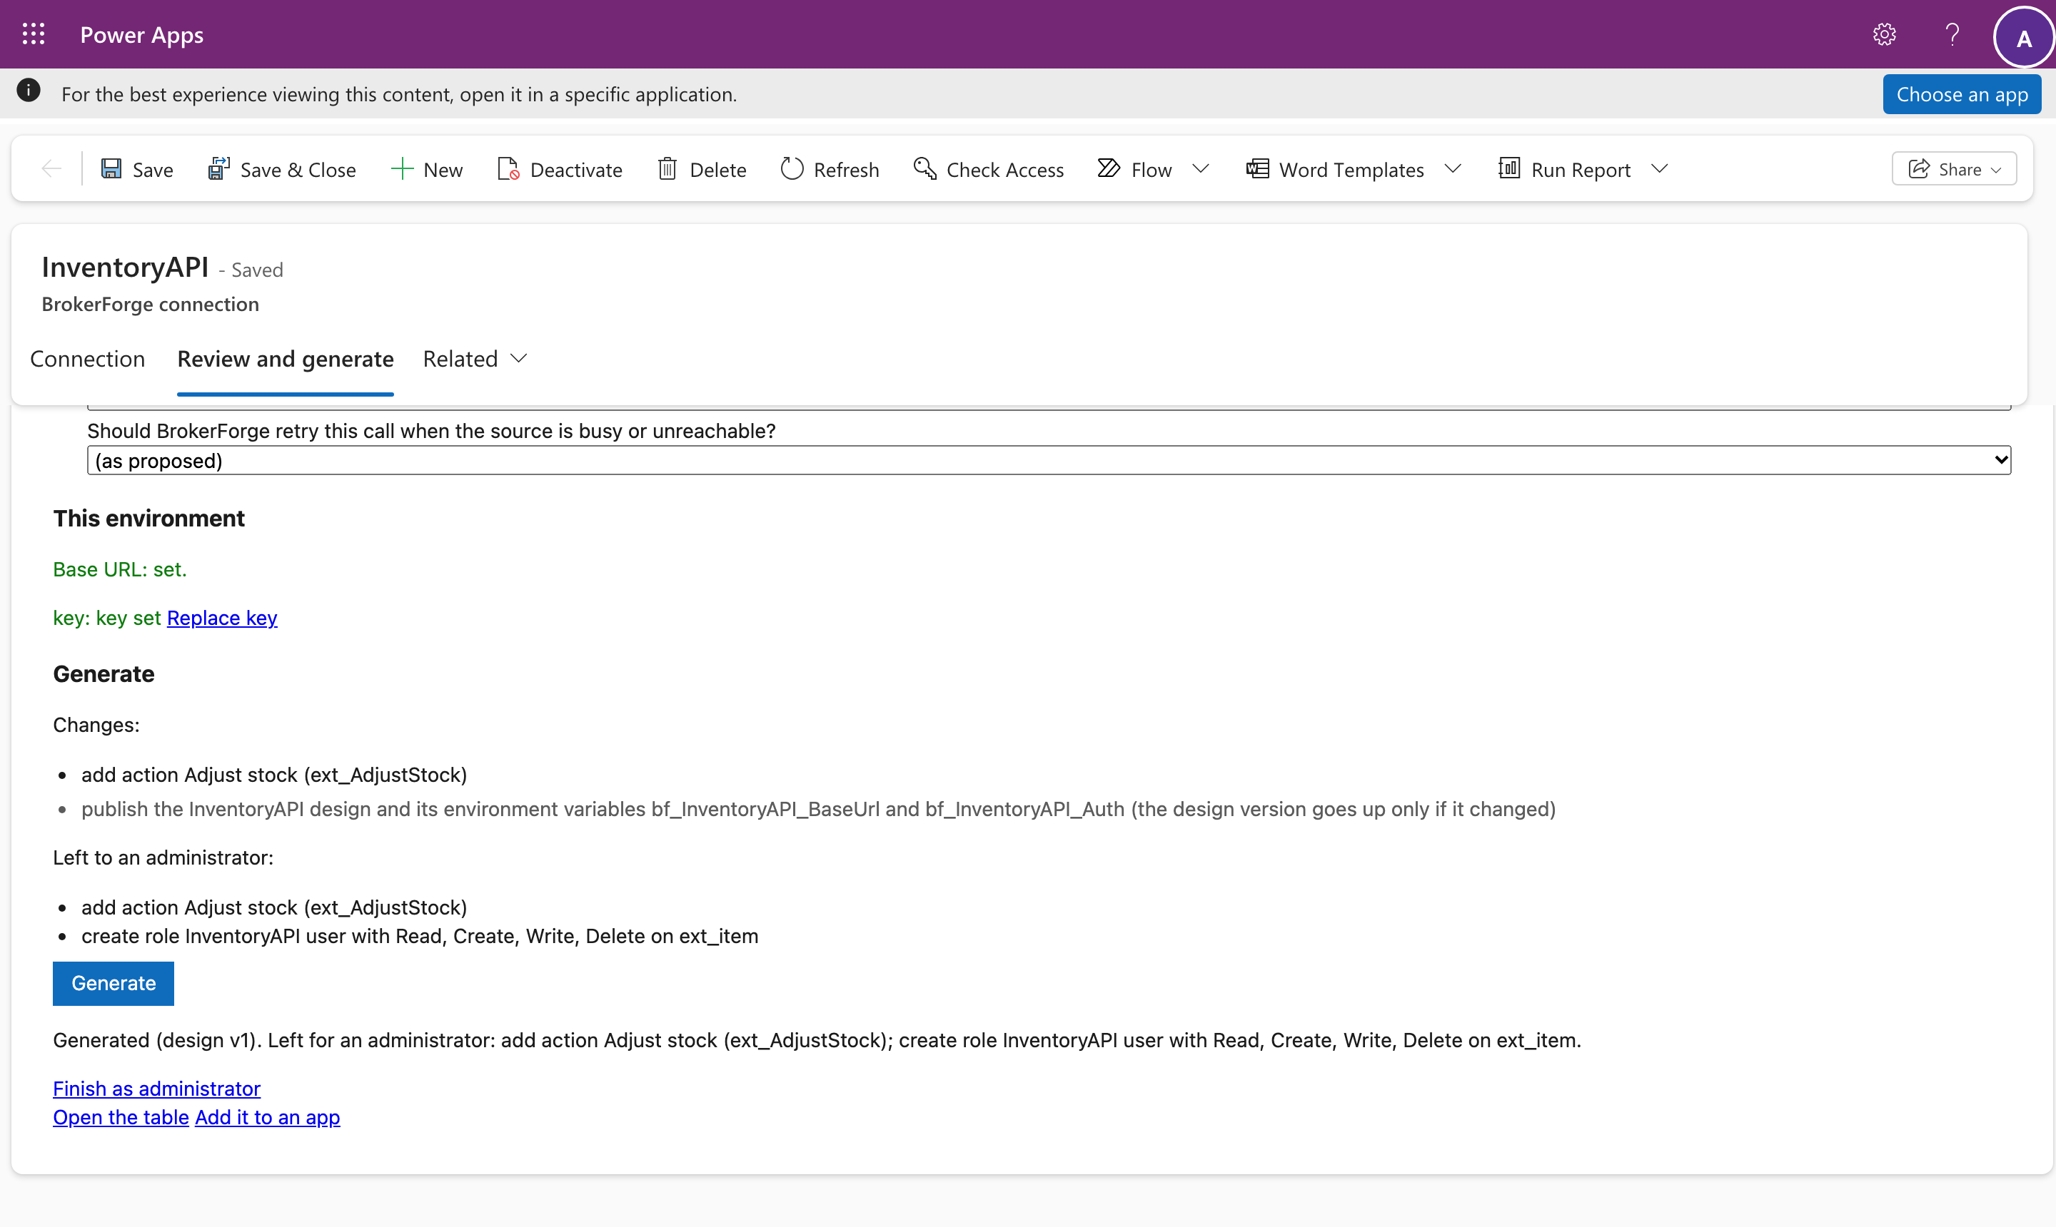
Two steps need an administrator's own rights: giving the role its privileges, and creating actions. The page lists them and offers Finish as administrator. It opens the host's page; select Do it as me, sign in for Dataverse (the first time, you're asked to allow BrokerForge Connect to access Dataverse as you), and both are done as you.
If you change the definition later, Save and read the definition again: the page lists what would change (a column added, removed or changed) before anything is applied. A column that something outside BrokerForge still uses, such as a hand-made view, is blocked and named, and nothing is applied until it's free.

Step 4: set the key
The connection shows needs key. Select Set key: the host's page opens, you sign in, and you enter the key there. It's stored encrypted by the host and never enters Dataverse. Back on the connections page the connection is ready.
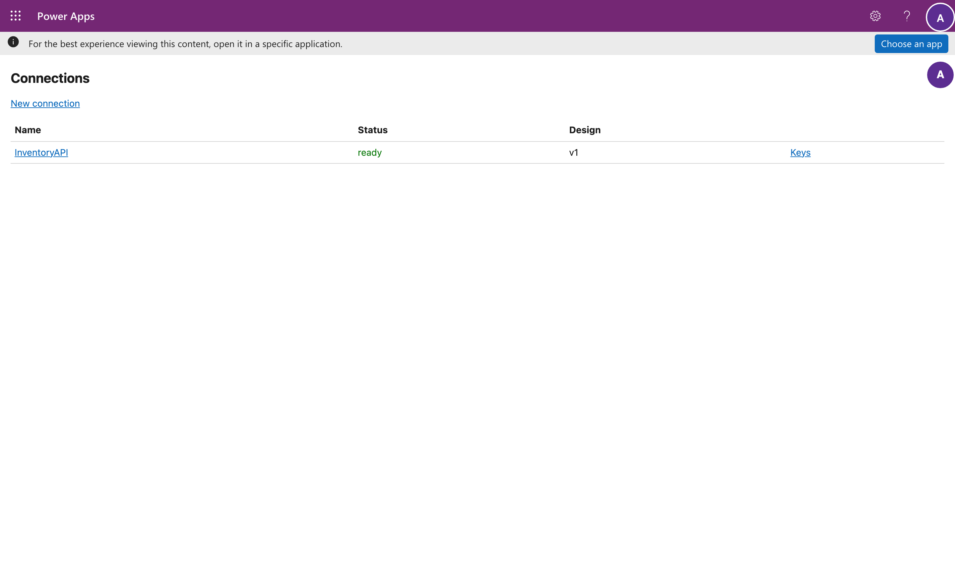

Step 5: use the table
The table lists rows straight from the API, and opening a record reads it. Save, New and Delete go to the API too. Nothing is copied into Dataverse.
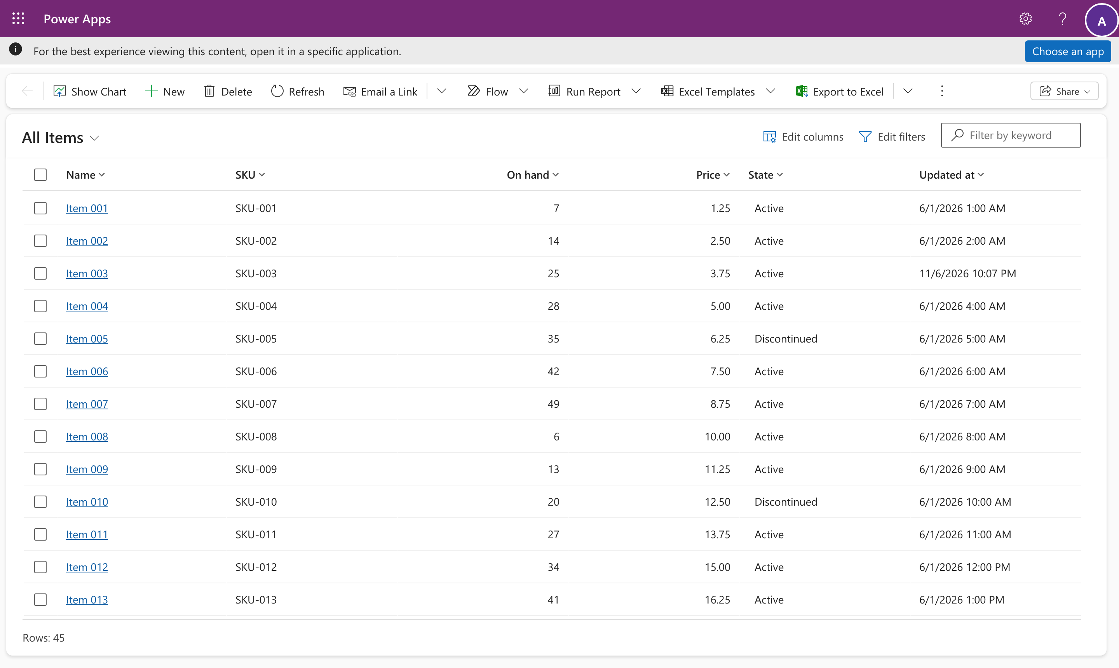
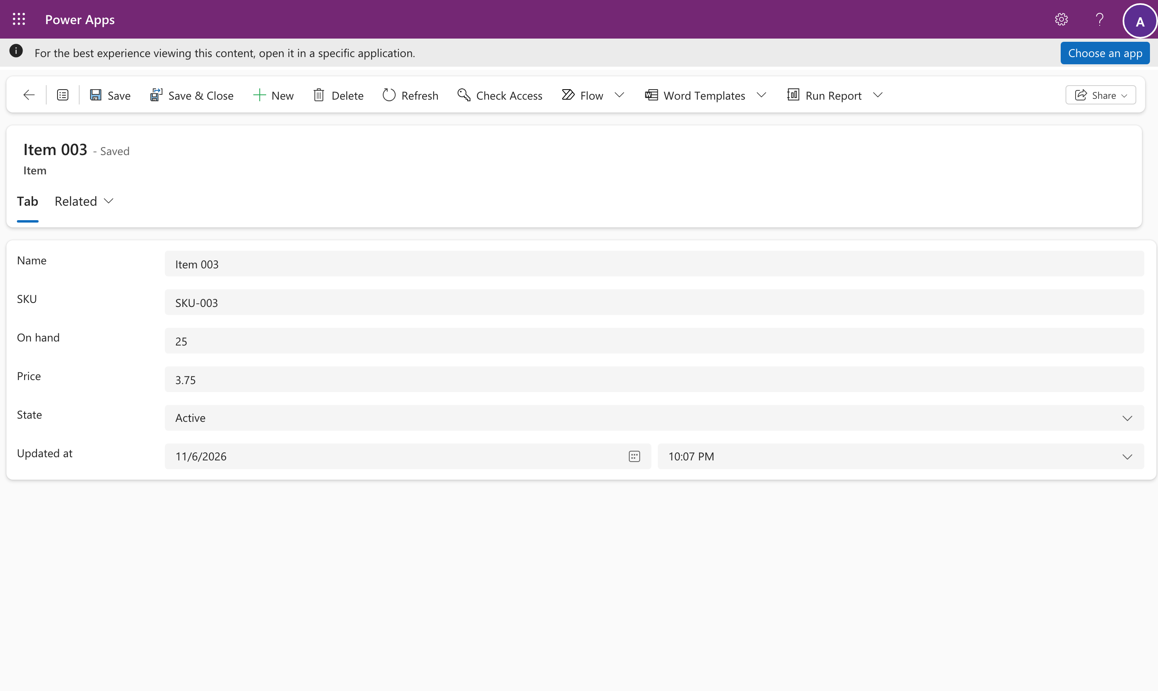
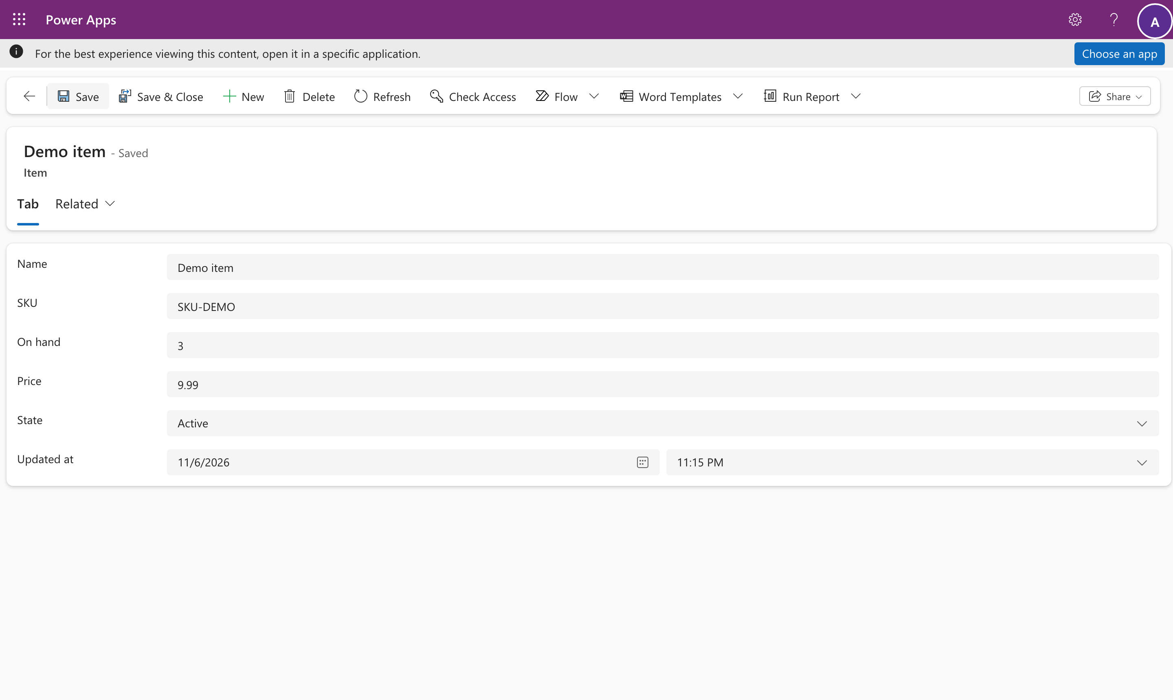

Test and production
The connection travels in its solution. Export it from dev and import it into test. There, set the environment variable bf_<Name>_BaseUrl if the API's address differs, then set the key on the connections page. Until then the connection says needs URL or needs key, and its tables fail with a configuration error naming what is missing. They never call the dev API.

What fails, and why
BrokerForge never returns partial or guessed results. A filter, sort or operator that wasn't declared in the answers is refused with a named error and a correlation ID for the host logs.

Per-user services
When each person must see only their own data, choose a per-user mode:
Mode | The user | The host sends
OAuth | signs in to the service once | that user's token from the service
Impersonate | signs in with their work account | a Microsoft Entra token for the service, as that user
SSO | enters their username and password for the service | those

Give users the generated role, and send them the connect page: https://<host>/connect/<Name>. There is no fallback: a user who hasn't connected gets a message asking them to, never someone else's data.

Part 2: connect your account (everyone)
The example is the Tickets table: each person sees the tickets their own Tickets account can see.
- Open the table. Until you connect, it shows an error with the connect page address instead of rows.
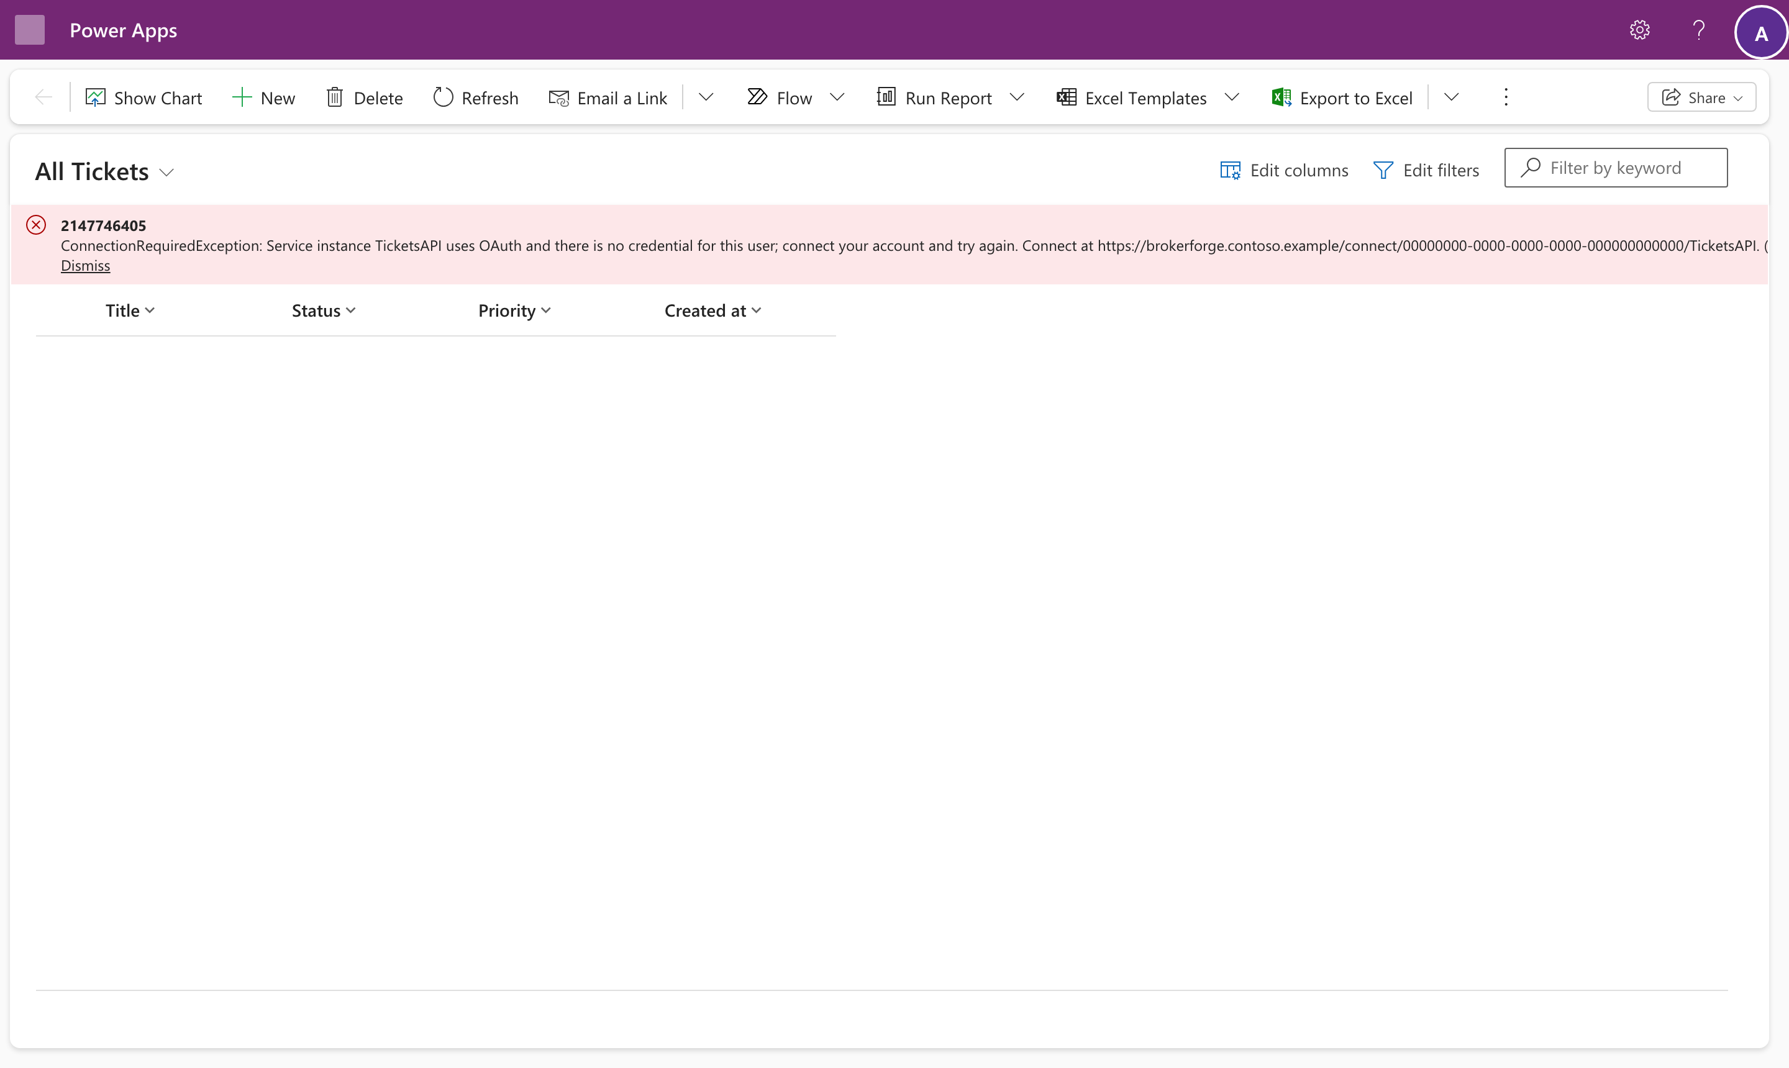
- Open that address. It signs you in with your work account and shows your connection's status. Select Connect.
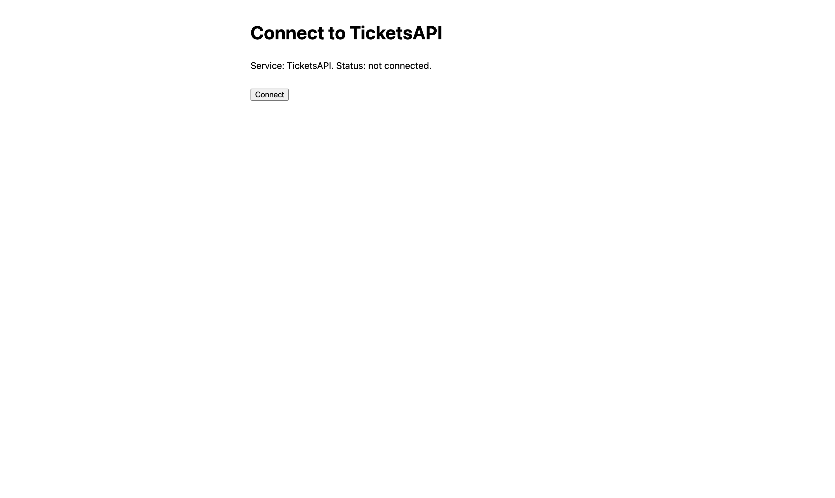
- Sign in to the service. (The demo service has its own simple page; a real one shows its own.)

- You're back on the connect page: connected. Your sign-in is stored encrypted, for you only, and renewed when it expires.
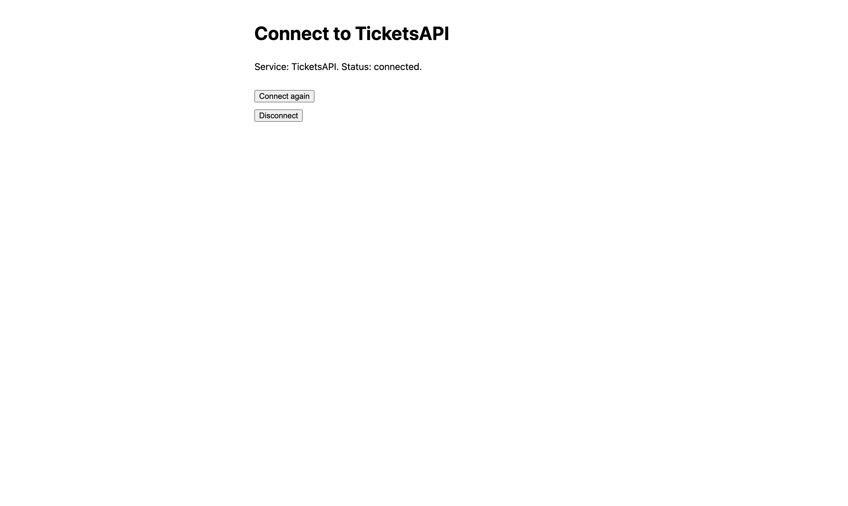
- Refresh the table: it shows your tickets. Records open on a form as usual.
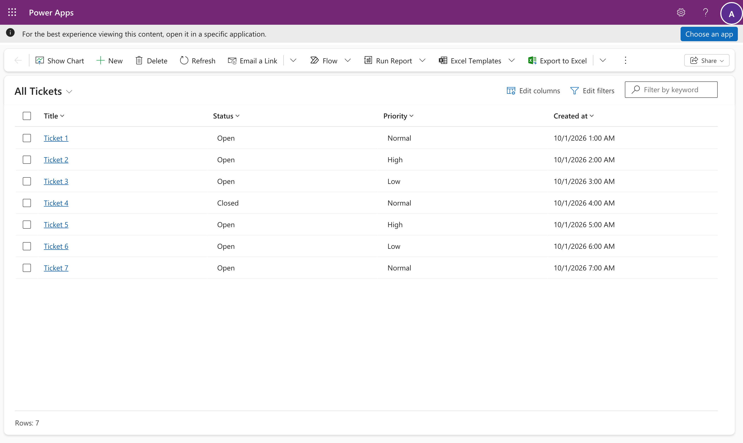
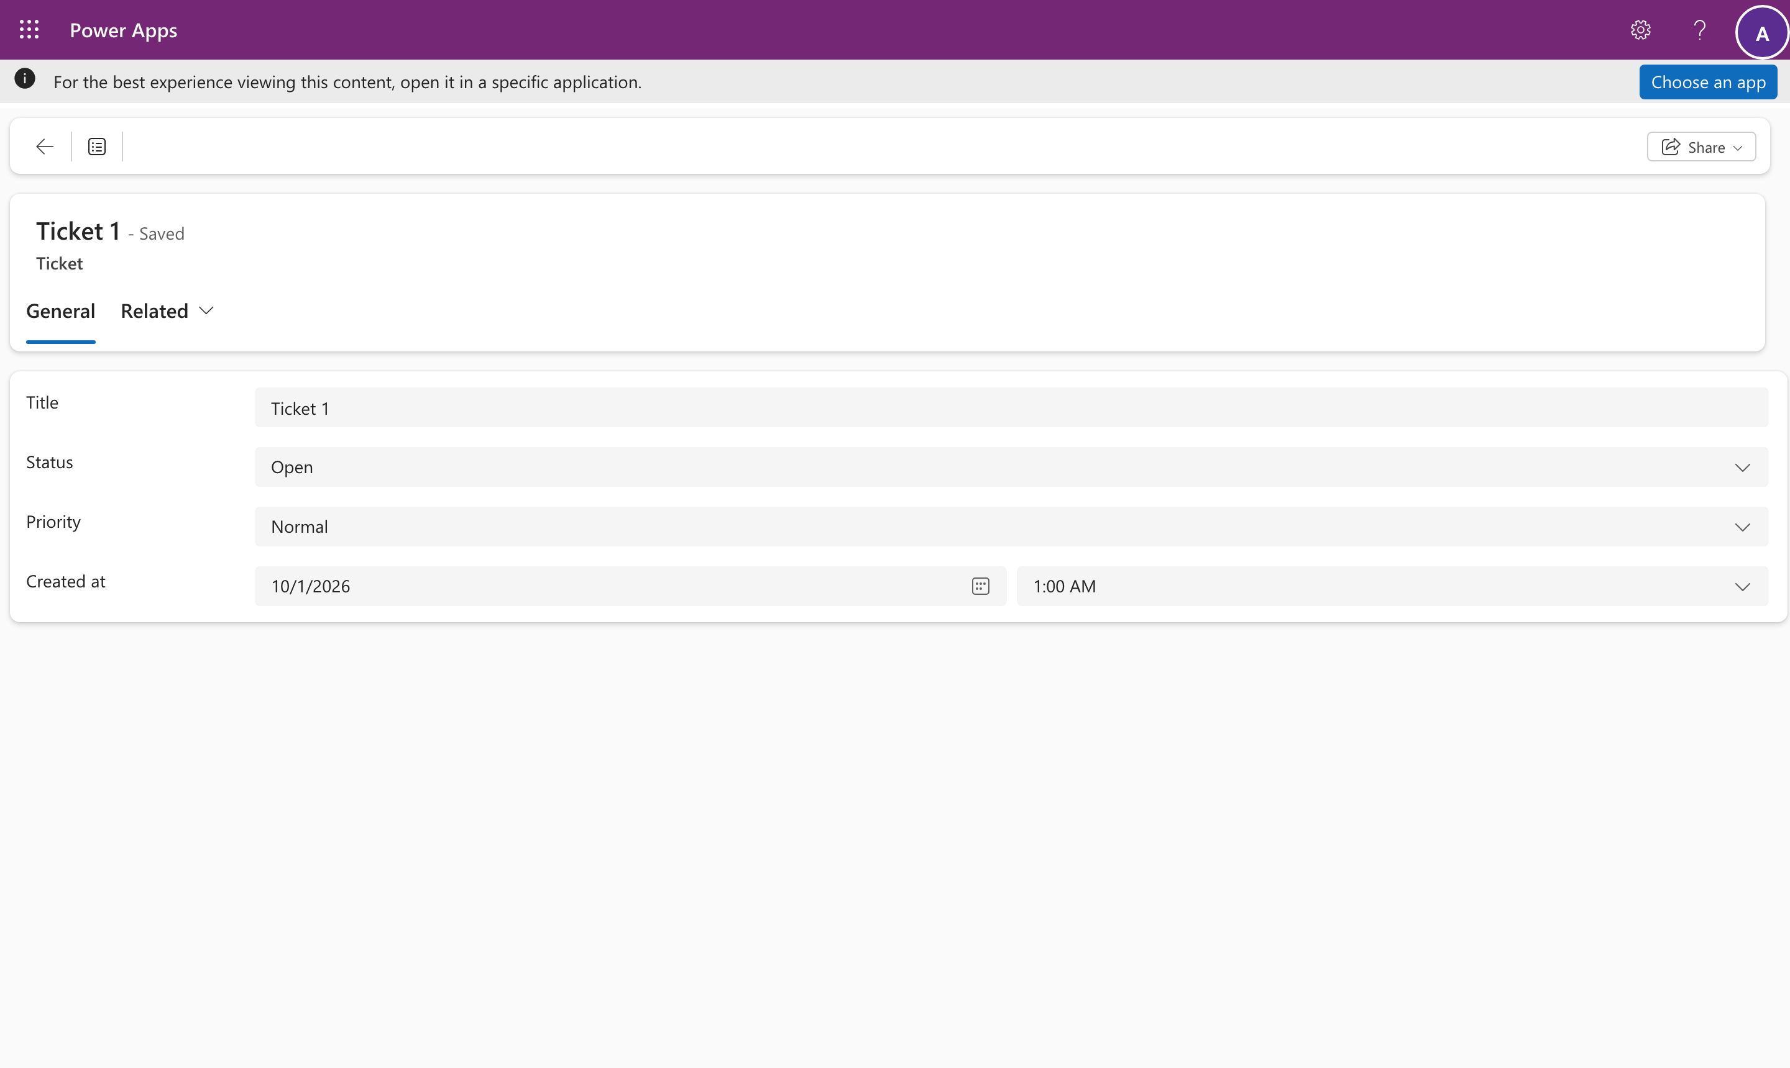
- The rows follow the account you connected. Connected as a different account at the service, the same table shows that account's tickets instead: each person sees their own.
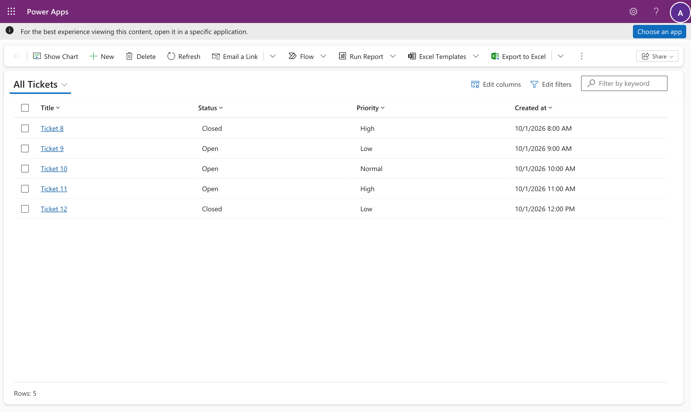
- To disconnect, open the connect page and select Disconnect. The list and forms ask you to connect again.
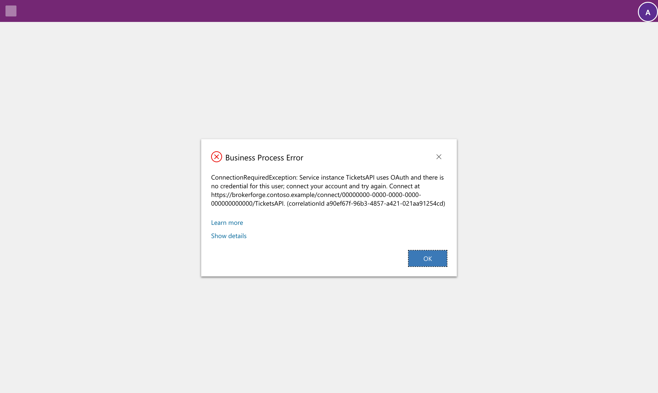
Sign in to the connect page with the same work account you use in Dataverse. If someone else is signed in to Microsoft in your browser, use a private window.

Where things live
What | Where
What you typed: name, URL, authentication, definition, answers | The connection row, in the environment you set it up in
What runs: the descriptors and table schema BrokerForge made | The connection's design, in the source's solution
Base URL in each environment | Environment variable bf_<Name>_BaseUrl
API keys and secrets | The host's encrypted store (set on the host's page)
Users' connections | The host's encrypted store

When something goes wrong
Message | Meaning | What to do
ConnectionRequiredException | You haven't connected to this per-user service, or the connection expired | Open the connect page in the message
UnsupportedQueryException | That filter, sort or operator isn't declared | Use a declared one, or ask an administrator to allow it in the connection's answers
SourceException | The service answered with an error | Give the correlation ID to an administrator
SourceTimeoutException | The service didn't answer in time | Try again
BrokerUnavailableException | Dataverse couldn't reach BrokerForge | Try again; in dev the first call after a pause takes about 25 seconds
ConfigurationError: the source "needs its base URL" or "needs its key" | The connection arrived in this environment without its URL or key | An administrator sets the variable, or the key on the connections page
MappingException | The service's answer didn't match its definition | An administrator checks the definition and reads it again

Every message ends with a correlation ID, which finds the request in the host logs.

